C8502 Graphics Coursework

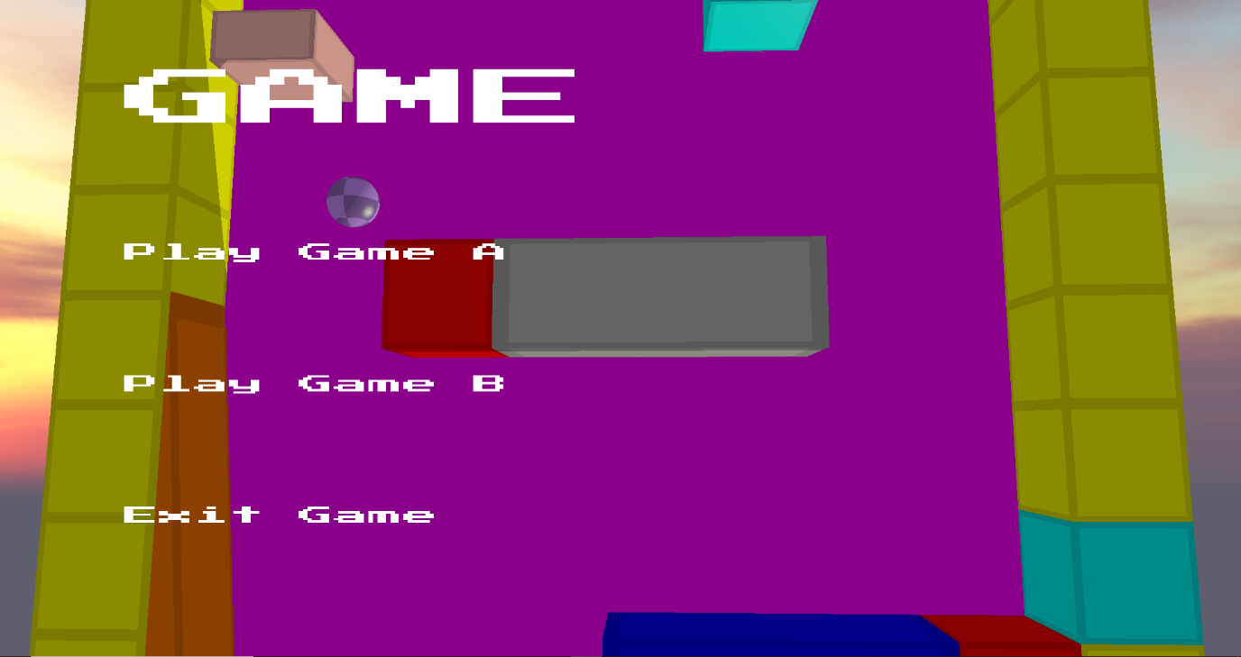

Title Screen, Pushdown Automata, click to choose which game to play and push a new game state

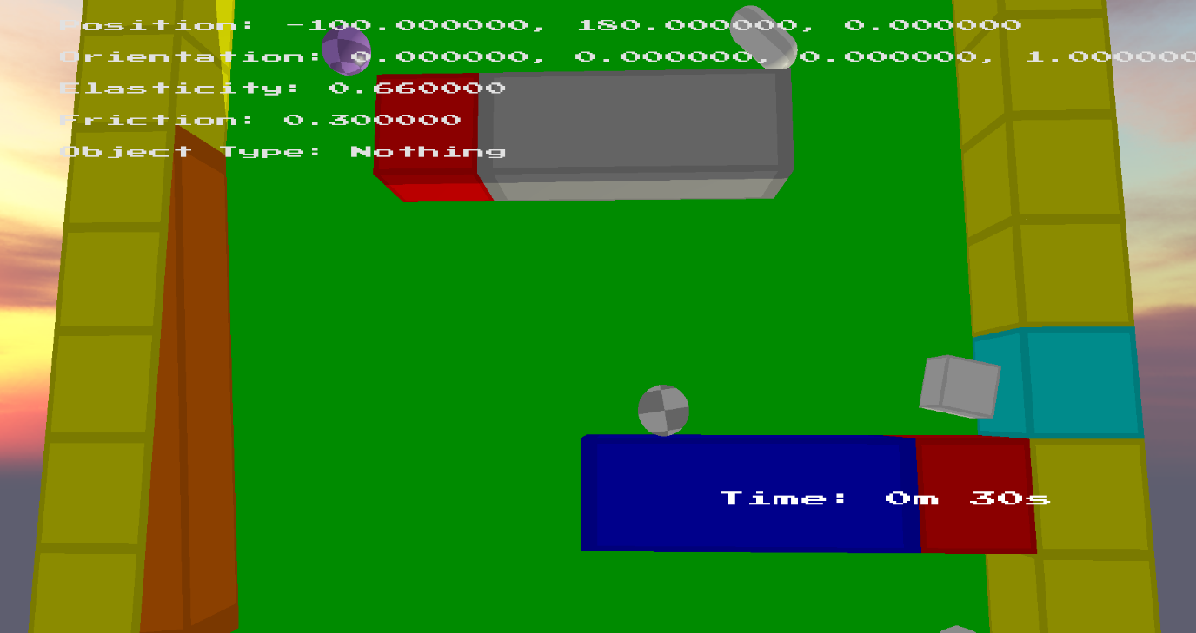

Middle of Physics Game, Capsule and OBB interactions, multiple Objects which push, pull, change gravity, shrink, change friction, spin. OBB cubes have smaller elasticity than others.

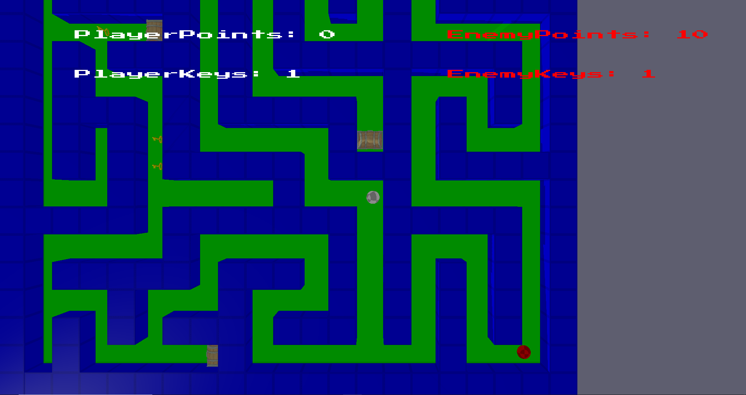

Middle of AI game, AI finds closest key, then moves to closest chest to increase its points. If your ball gets too close it will chase you. Both respawn when colliding, player loses points. Done using behaviour trees and pathfinding.

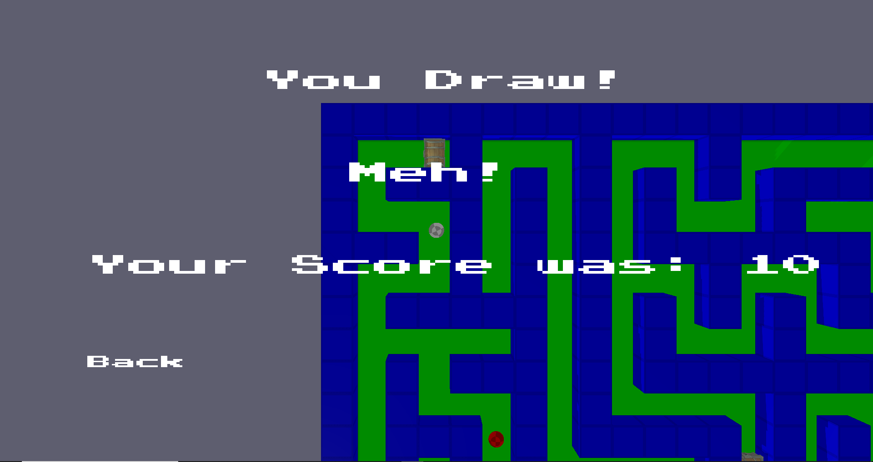

End screen upon completing AI game, changes depending on your score vs enemies, back sends you to title screen.

Keybinds:

M - Enable/Disable Free Camera

W - Move camera forward

A - Move camera left

S - Move camera back

D - Move camera right

Space - Move camera up

Shift - Move camera down

Mouse – rotate camera

P – Pause Game

Game A

O – activate Hookshot

U – change Hookshot direction

Space (and hold) – Use Hookshot

Left Click – Show Debug info / activate object ability

Game B

Up – Move Ball Up

Down – Move Ball Down

Left – Move Ball Left

Right – Move Ball Right